**DATA:**

* Use 100 randomly generated two dimensional points in 1.0 <= x, y <= 100.0 and K = 3.

**SEED:**

* Seed is used 1,2,3,4 and 5 accordingly for the reproducibility.

**ALGORITHM AND PROPERTY DESCRIPTION**

* Simulated Annealing Clustering is implemented with
$$K=3, Temperature=1000, coolingRate=0.03$$

* Acceptance probability is calculated as follow
$${P_{accept}= e}^{\frac{(prevIntraDist-currentIntraDist)}{Temperature}}$$

* Every iteration, the temperature drops 3 percent
* Loop continues, until the temperature is becomes less than one

**GRAPH:**

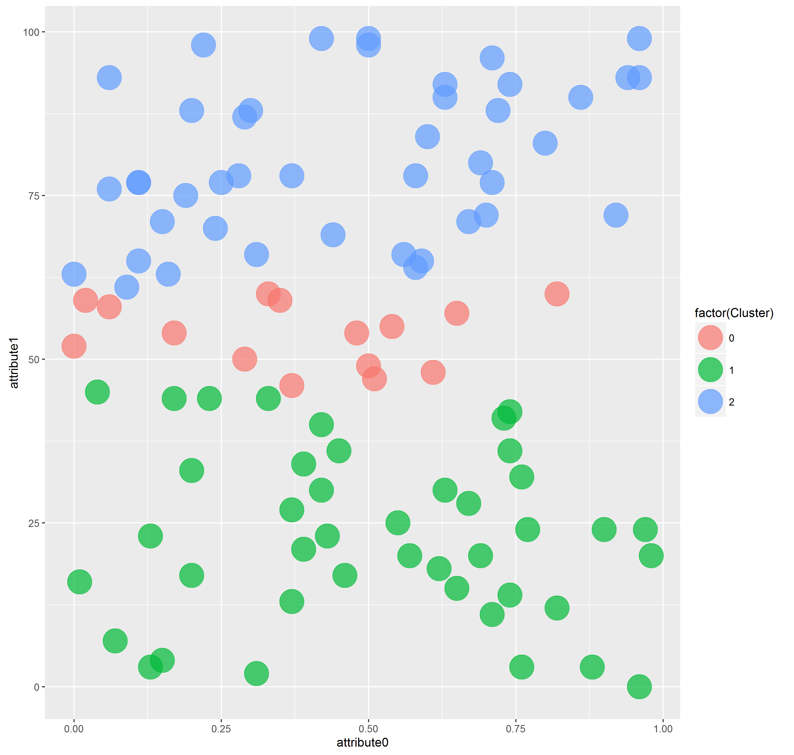

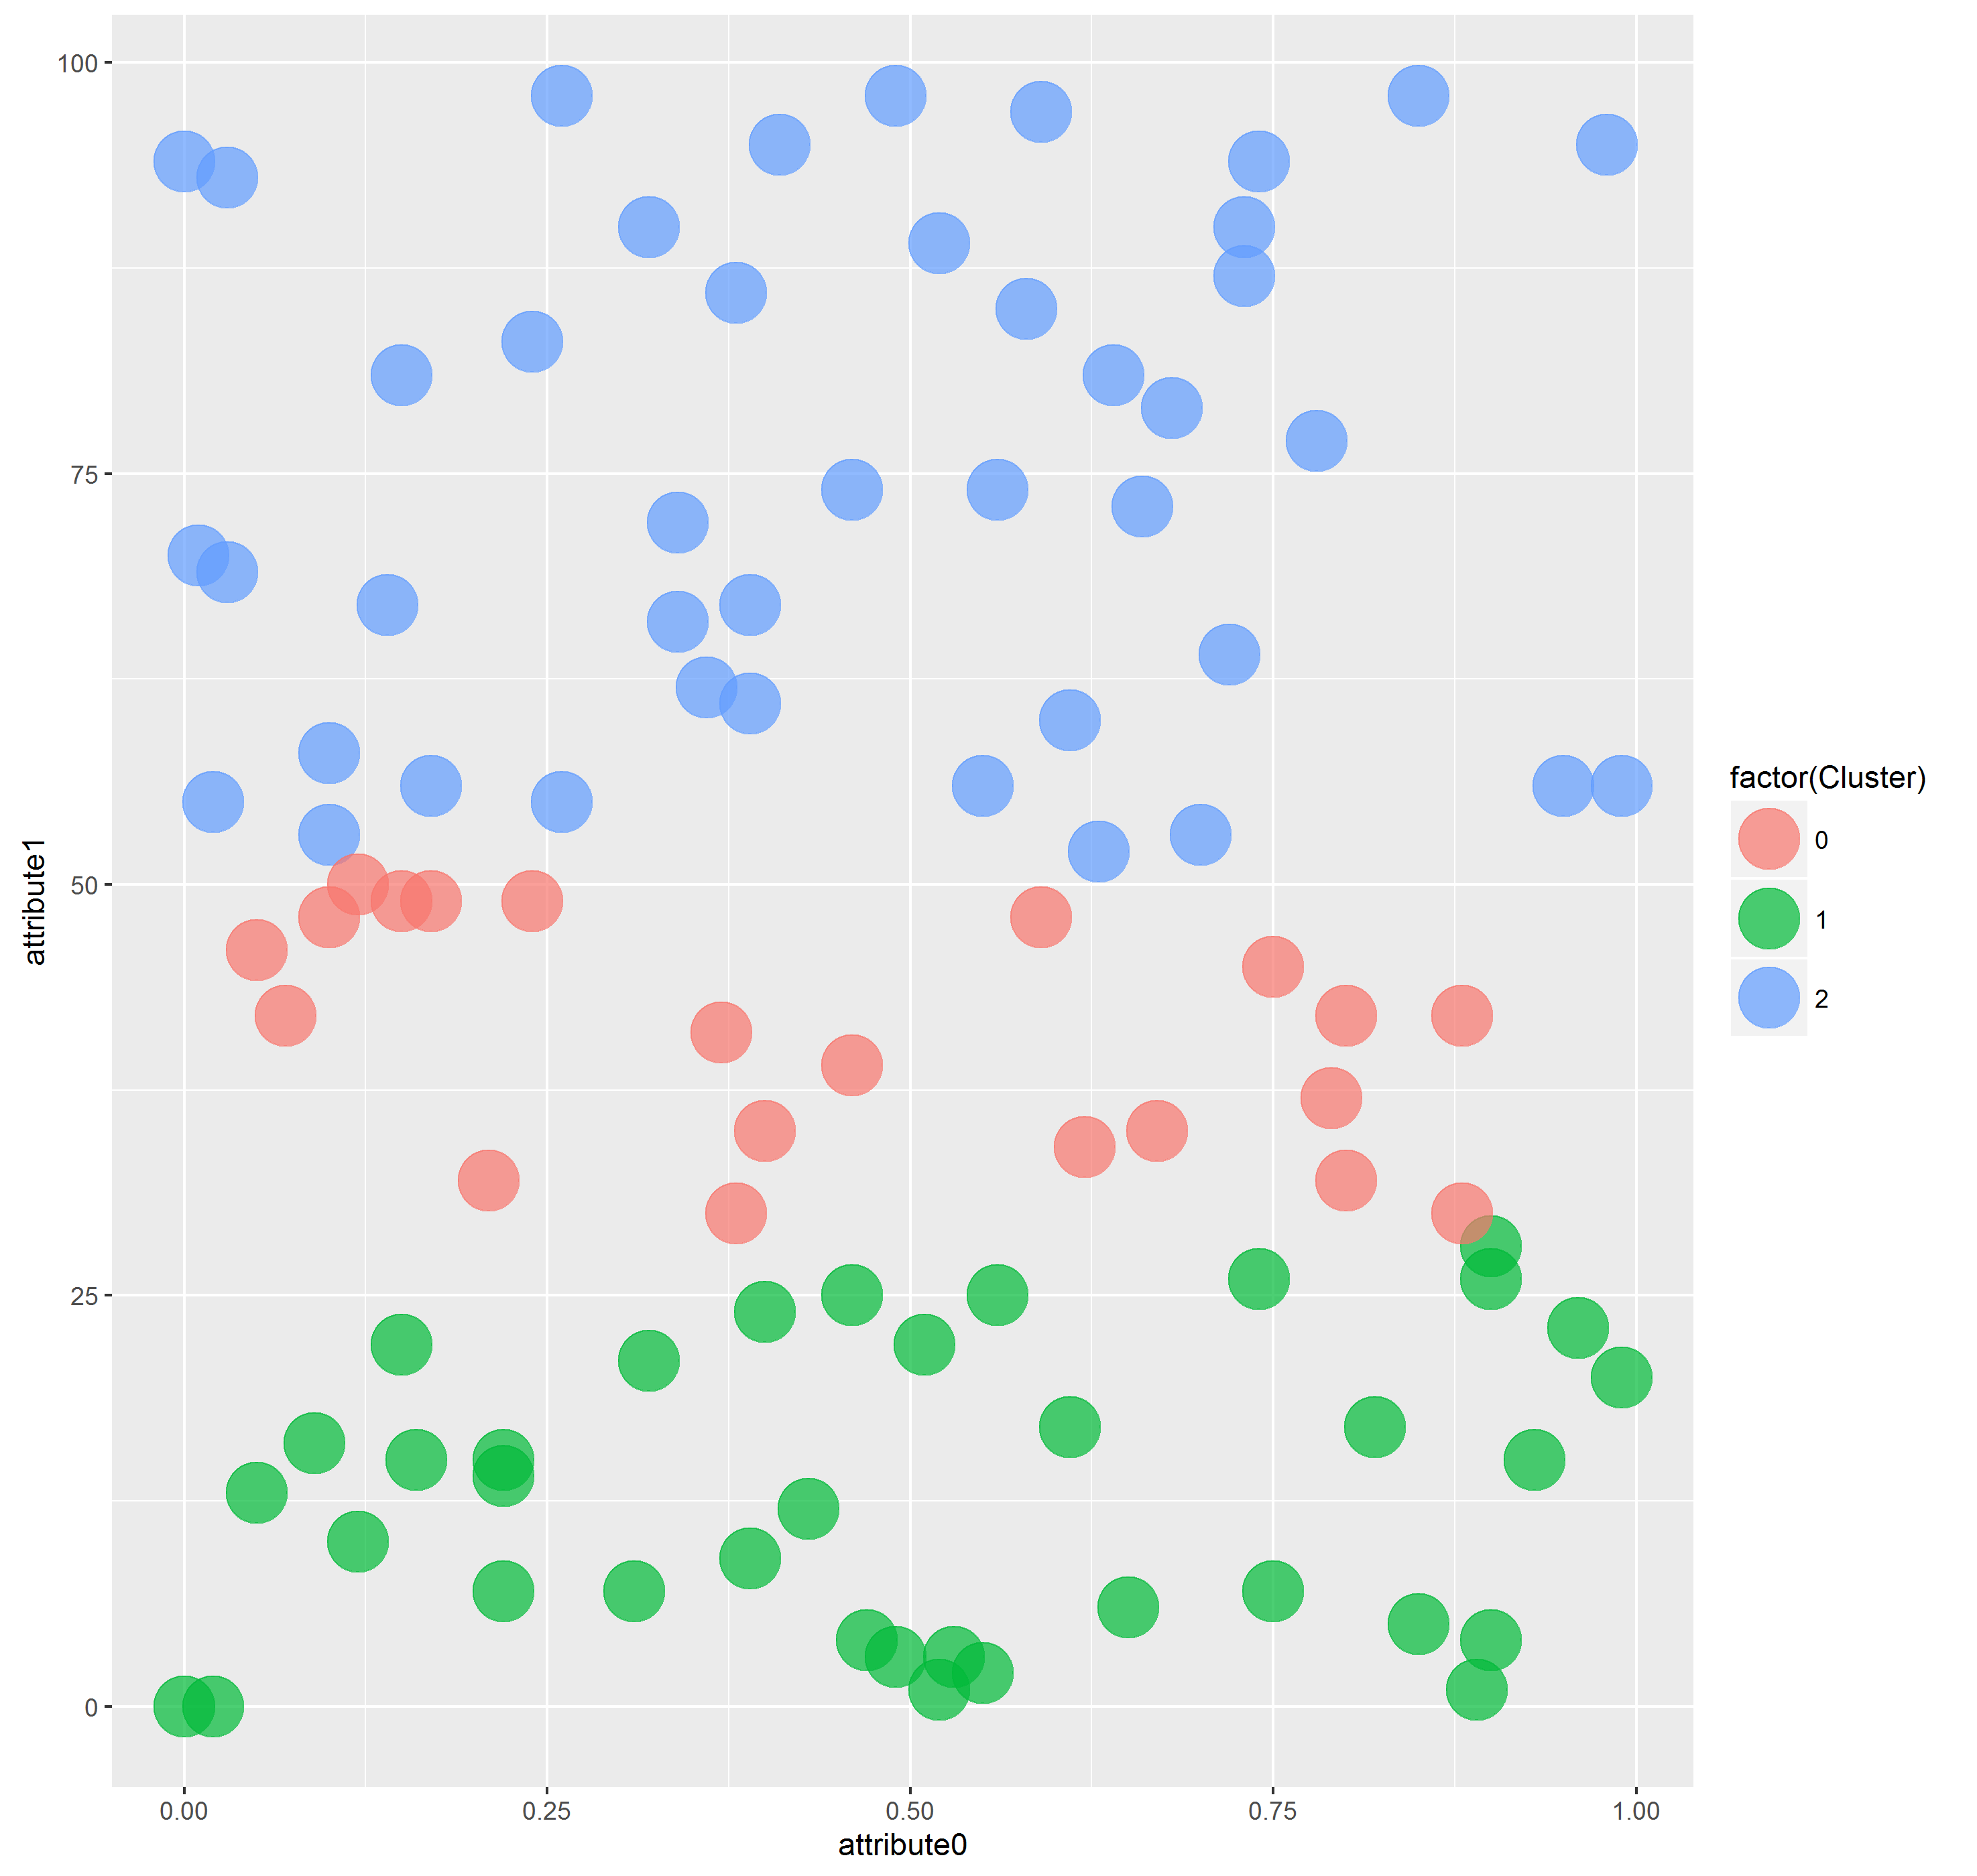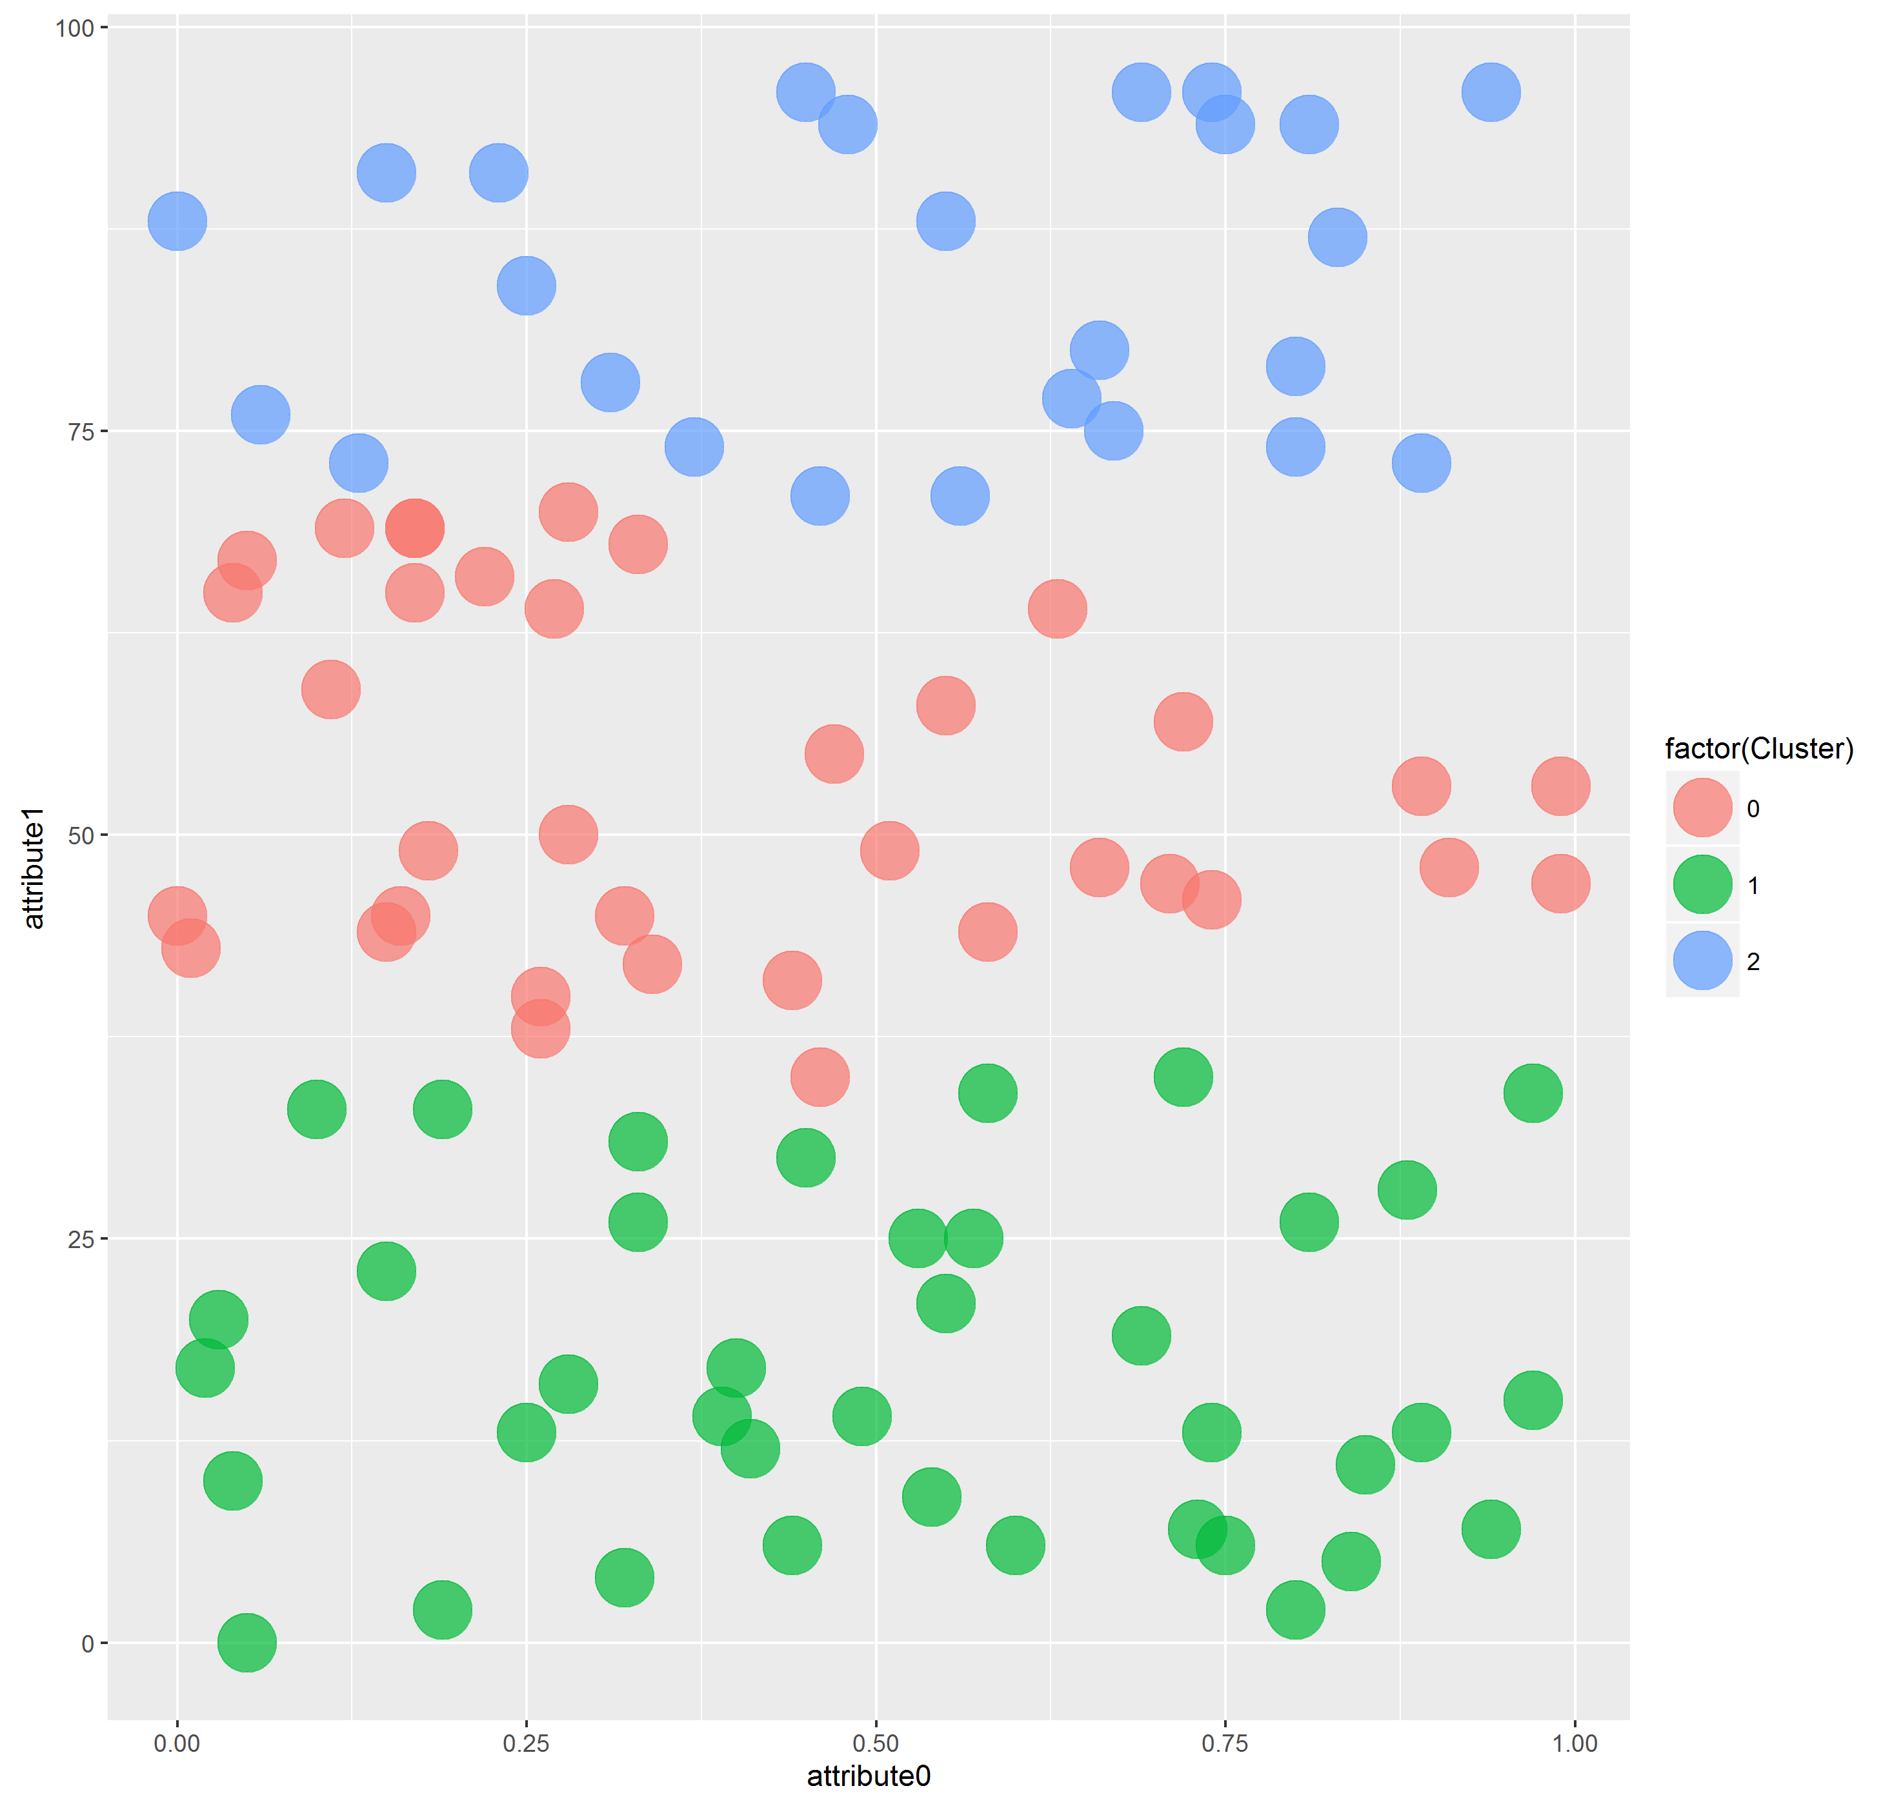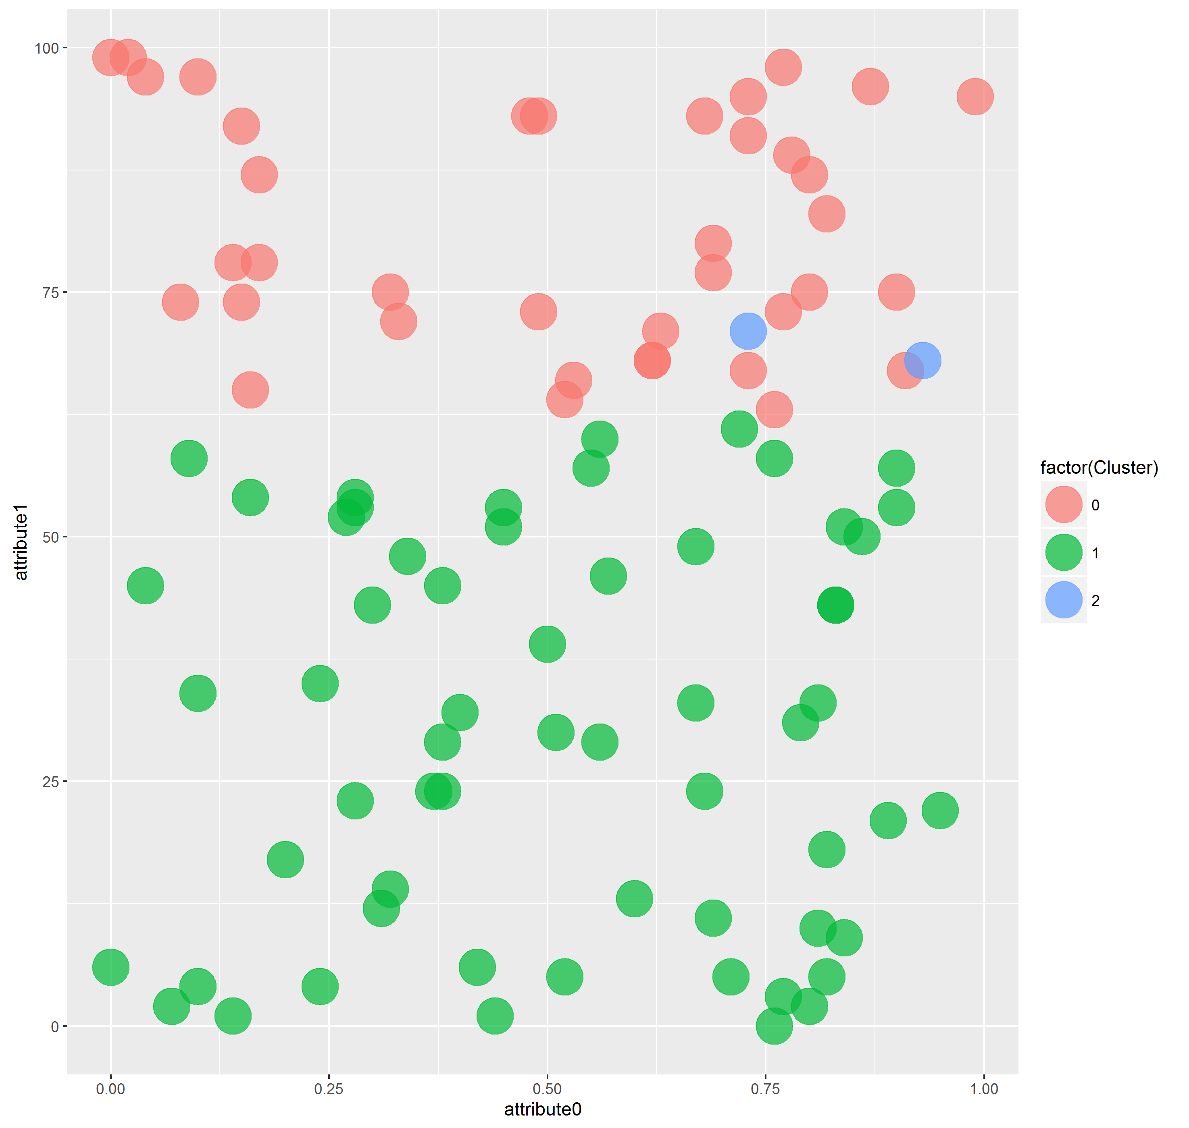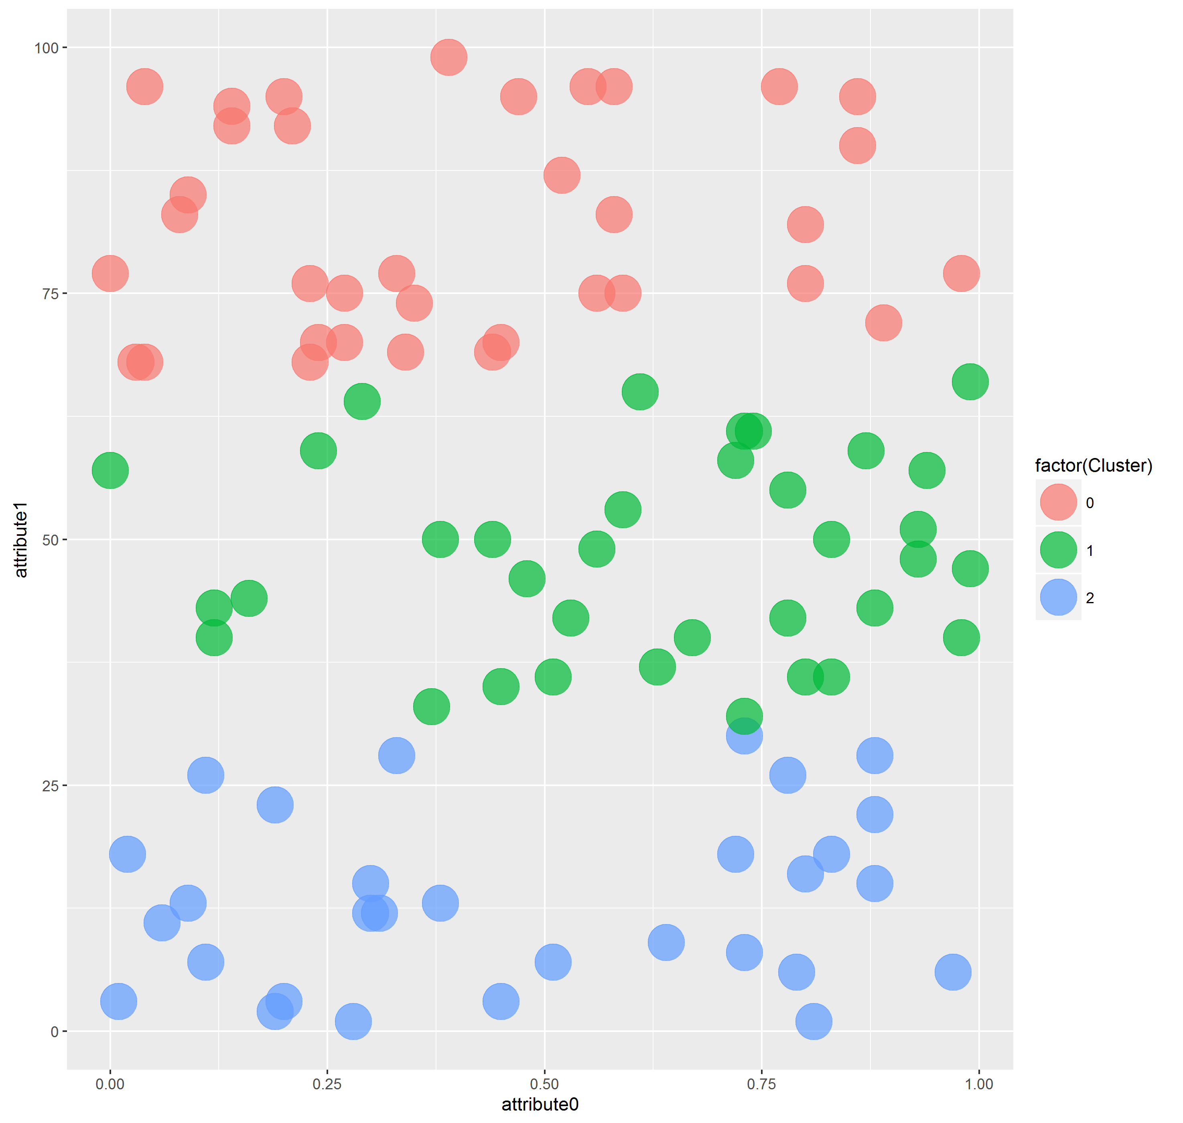

**CONSOL OUTPUT:**

* The console output is attached as

output1.txt, output2.txt, output3.txt, output4.txt, output5.txt

**CODE:**

* The original code is attached as

Main.java, SAcluster.java, plot.r